**Session report 14/12/2022:**

*LABAUVIE – RAFFAELLI EVA*

*ROB3*

Like the previous session I’m still trying to find a way to modelise properly this system to eventually print it and add it to our robot :

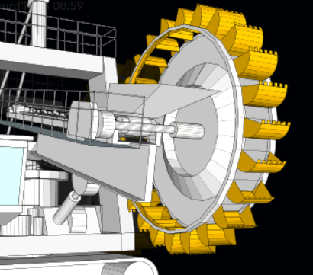

Last time I created the outside wheel, today I will try to get a proper collecter.

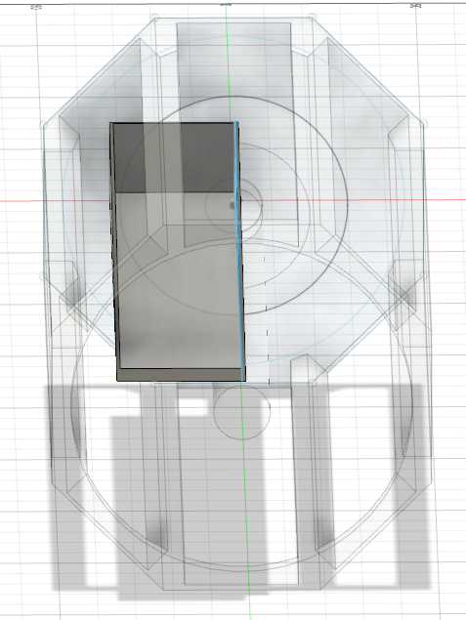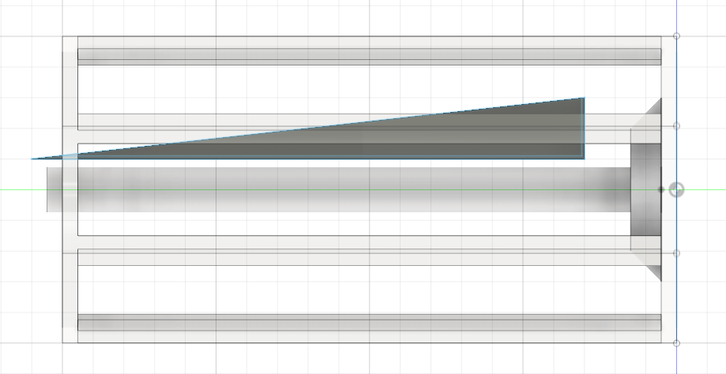

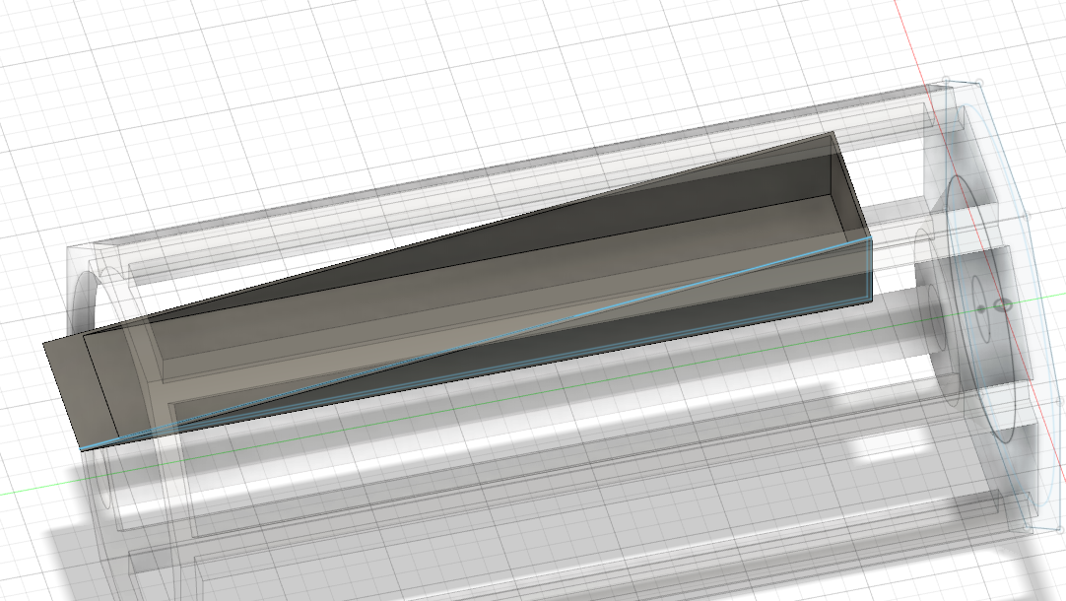

The collector will rest on the conveyor to carry the rubbish and get them sorted.

I made thin holes in the collector so the sand can go through.

I just realised I made a mistake and didn’t incline thr right part of the receiver so I need to retouch the collector so it’s inclines to allow the rubbish to go down.